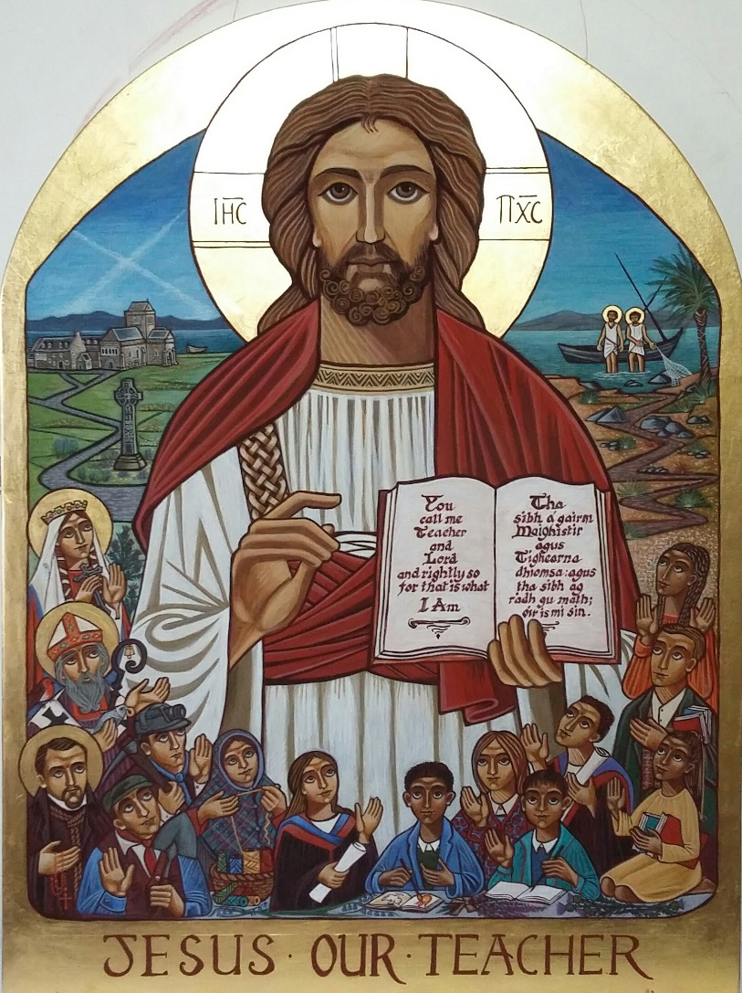

A Prayer of Grateful Thanks for our Heritage

Let us pray, mindful of those who have gone before us, our ancestors. In their witness may we be helped to respond to God’s call.

Our patron saints, Andrew and Margaret, give us the example of self-giving disciples of Jesus, always willing to reach out to others and not to count the cost. To these patron saints, through Christ our Lord we say:
Pray for us that we might, as Jesus taught us, welcome the stranger, the migrant and the poor.

The great saints, Columba, Mungo, Eunan and Ninian brought Christianity to our country and worked as missionaries bringing the faith and traditions of Catholicism to Scotland. To them, through Christ our Lord we say:
Thank you for your great work. Pray for us to hold our faith dear and always remain committed to Christ.

From 1775 to 1918 and onwards, the Irish left their homeland due to poverty and starvation. They came to Scotland and brought their strong faith, devotion and willingness to work in mining, roads, building sites and shipyards. To those Irish immigrants, through Christ our Lord we say:
Thank you for bringing your faith to us. Pray for us that we will hold on to that faith as we work in the Church as catechists.

From 1880 to 1940 and onwards the Italian, Lithuanian and Polish communities brought their faith with them as they travelled here escaping poverty, religious suppression and searching for a better life. To those Italian, Lithuanian and Polish migrants, through Christ our Lord we say:
Thank you for settling in our country and your bringing your faith to us. Pray for us that we might always welcome the stranger and share what we have.

We remember with love all those who taught in our Catholic schools before the 1918 Education Act, priests, sisters, brothers and laypeople who gave their lives so that children could have a Catholic education.
To all of them through Christ our Lord we say:
Thank you for sharing your faith and work with our forbearers. Pray for us that we may have courage to work hard in our calling as parish catechists so that we may help others to strengthen their relationship with Jesus.

We remember with appreciation all those who have worked in education since the 1918 Education Act was passed. To them through Christ our Lord we say:
We thank you for working so hard in laying the good foundation in our Catholic schools. Pray for us to always appreciate those who taught us and contributed to who we are today.

We thank our parents who passed on their faith to us as our first teachers and worked so that we would benefit from a Christian or Catholic education.
We pray for them that God will bless them with His peace.

Mary, mother of Jesus, our mother too. Called to a life of deep trust, she pondered in her heart the call of God, as we too are urged to ponder it. To Mary we say:
Give us a burning heart to respond to God’s call.

All: Our Father ….

