Saint
I am the patron saint of

______________________________________

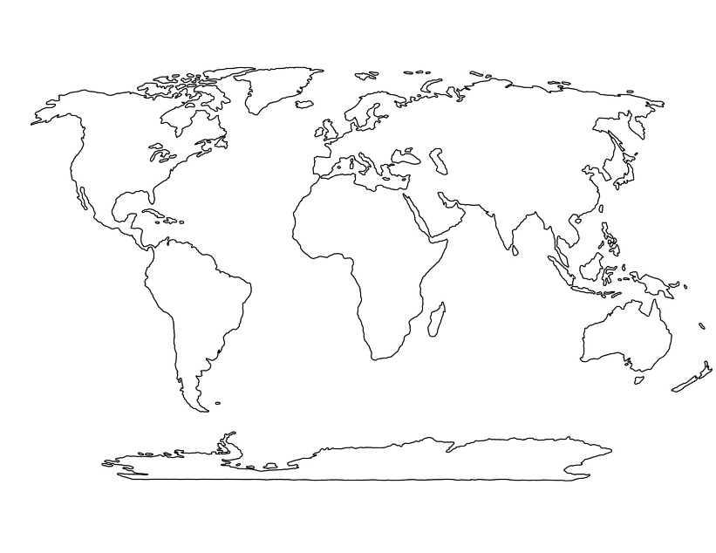
I was born in:

Facts: ______________________________________________________________________________________________________________________________________________________________________________________________________________________________________________

